Method of Moments in 2D analysis

for scattering by a conducting cylinder

**Abstract**: In this report, I use method of moments to study a 2D scattering problem, where the scatterer is an infinitely long conducting cylinder. The solved surface current distribution is compared with the analytical solution. Also, the bistatic scattering width is calculated, which is an important parameter charactering the scattering property of an infinitely long cylinder.

# Introduction

The MoM transforms a boundary-value problem into a matrix equation, in a different way from FEM. It used integral equations instead of a weak form of PDE. It is particularly well suited to open-region problems such as wave scattering and antenna radiation. Also, it is very efficient for problems involving either impenetrable or homogeneous objects.

# Problem set-up

An infinitely long conducting (PEC) cylinder of radius a is placed along z-axis centered at the origin. A plane wave is traveling along +x-axis. Here is a top view of the set-up,

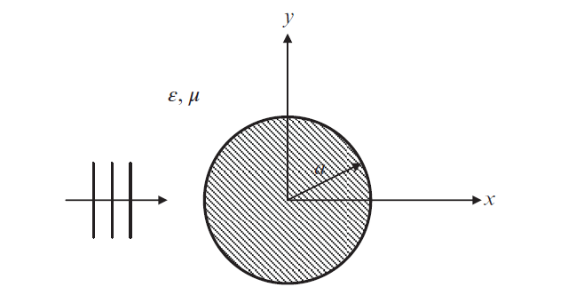

The incident wave can be decomposed into two polarization modes TM and TE, where TM has E-field only along z-axis, Ez, while TE has Hz as the only H-field. Outside the cylinder, there is only vacuum with ε = ε0, μ = μ0 .

# Integral Equation and MoM

As learned in class, for TM polarization, the governing equation outside the cylinder is

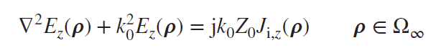

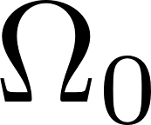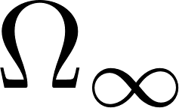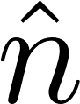

with boundary conditions,

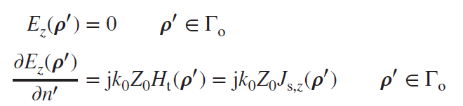

Using the general integral equation for the 2D Helmholtz equation, we get,

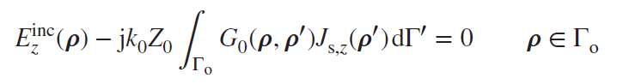

Now we have the unknown as a surface current distribution in the integral equation. By representing it in terms of local bases, and doing Galerkin's testing, we can get a matrix equation. Same for TE polarization, the integral equation is

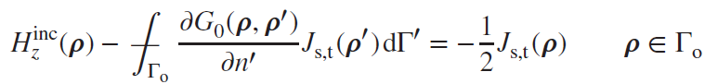

Here, we use uniform segments of constant J over each segment as the boundary elements on the surface of the scatterer. The test is carried out at the center of each segment. Also, the integration is approximated using the midpoint value. Thus, we have, for TM

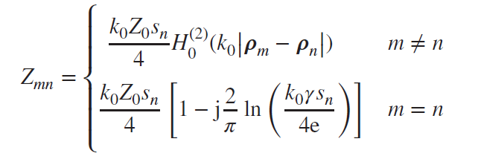

For TE,

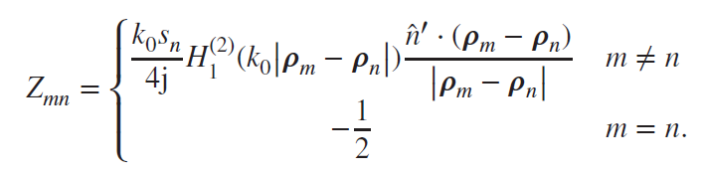

# Results and Discussions

Here, I attach the results for a = λ, the surface is discretized into N = 500 elements.

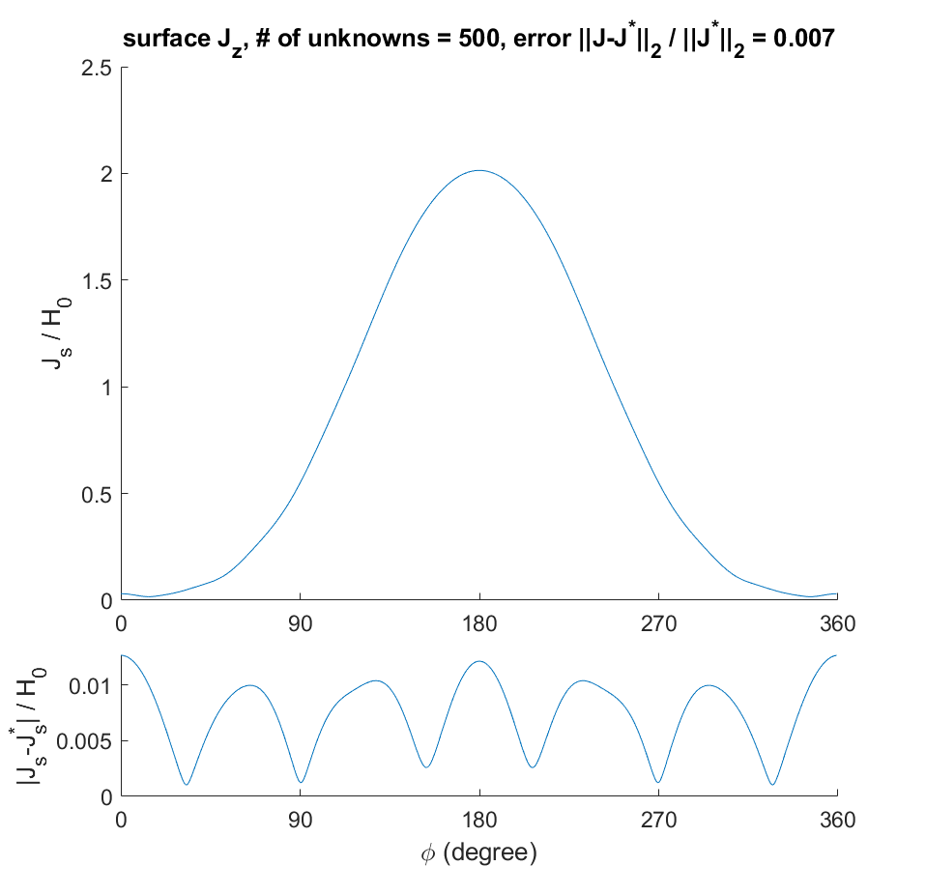 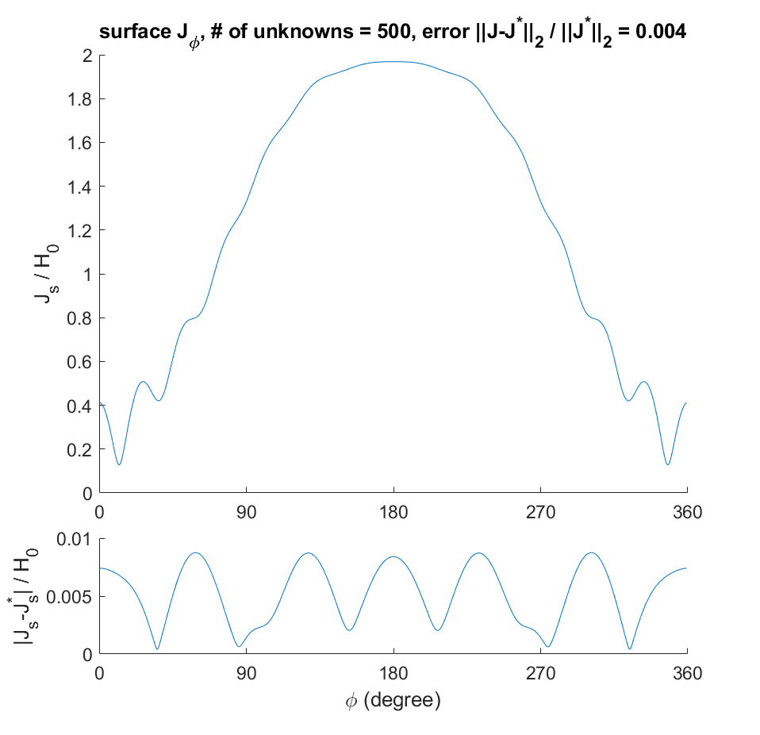

TM

TE

Here the result represents |J()| / Hinc.

Also, the MoM solution is compared with the analytical solutions, in the lower panels. The analytical solutions are summed up to 81 terms in each series, from n = -40 to +40, based on Equ 6.4.12, Equ 6.4.20 in Ref [1]. The following plots of coefficients in the analytic solution series explain why |n| = 40 is well enough.

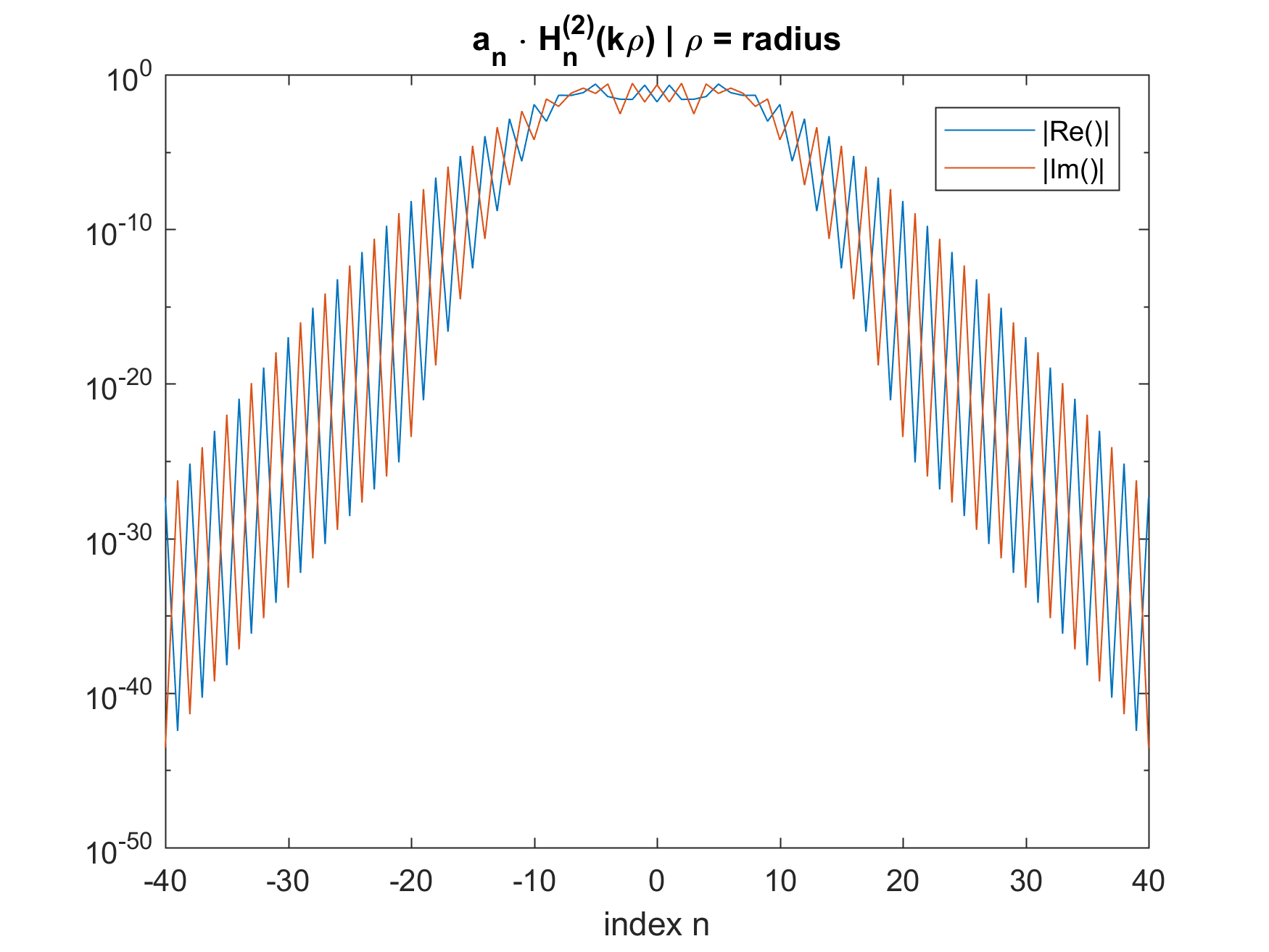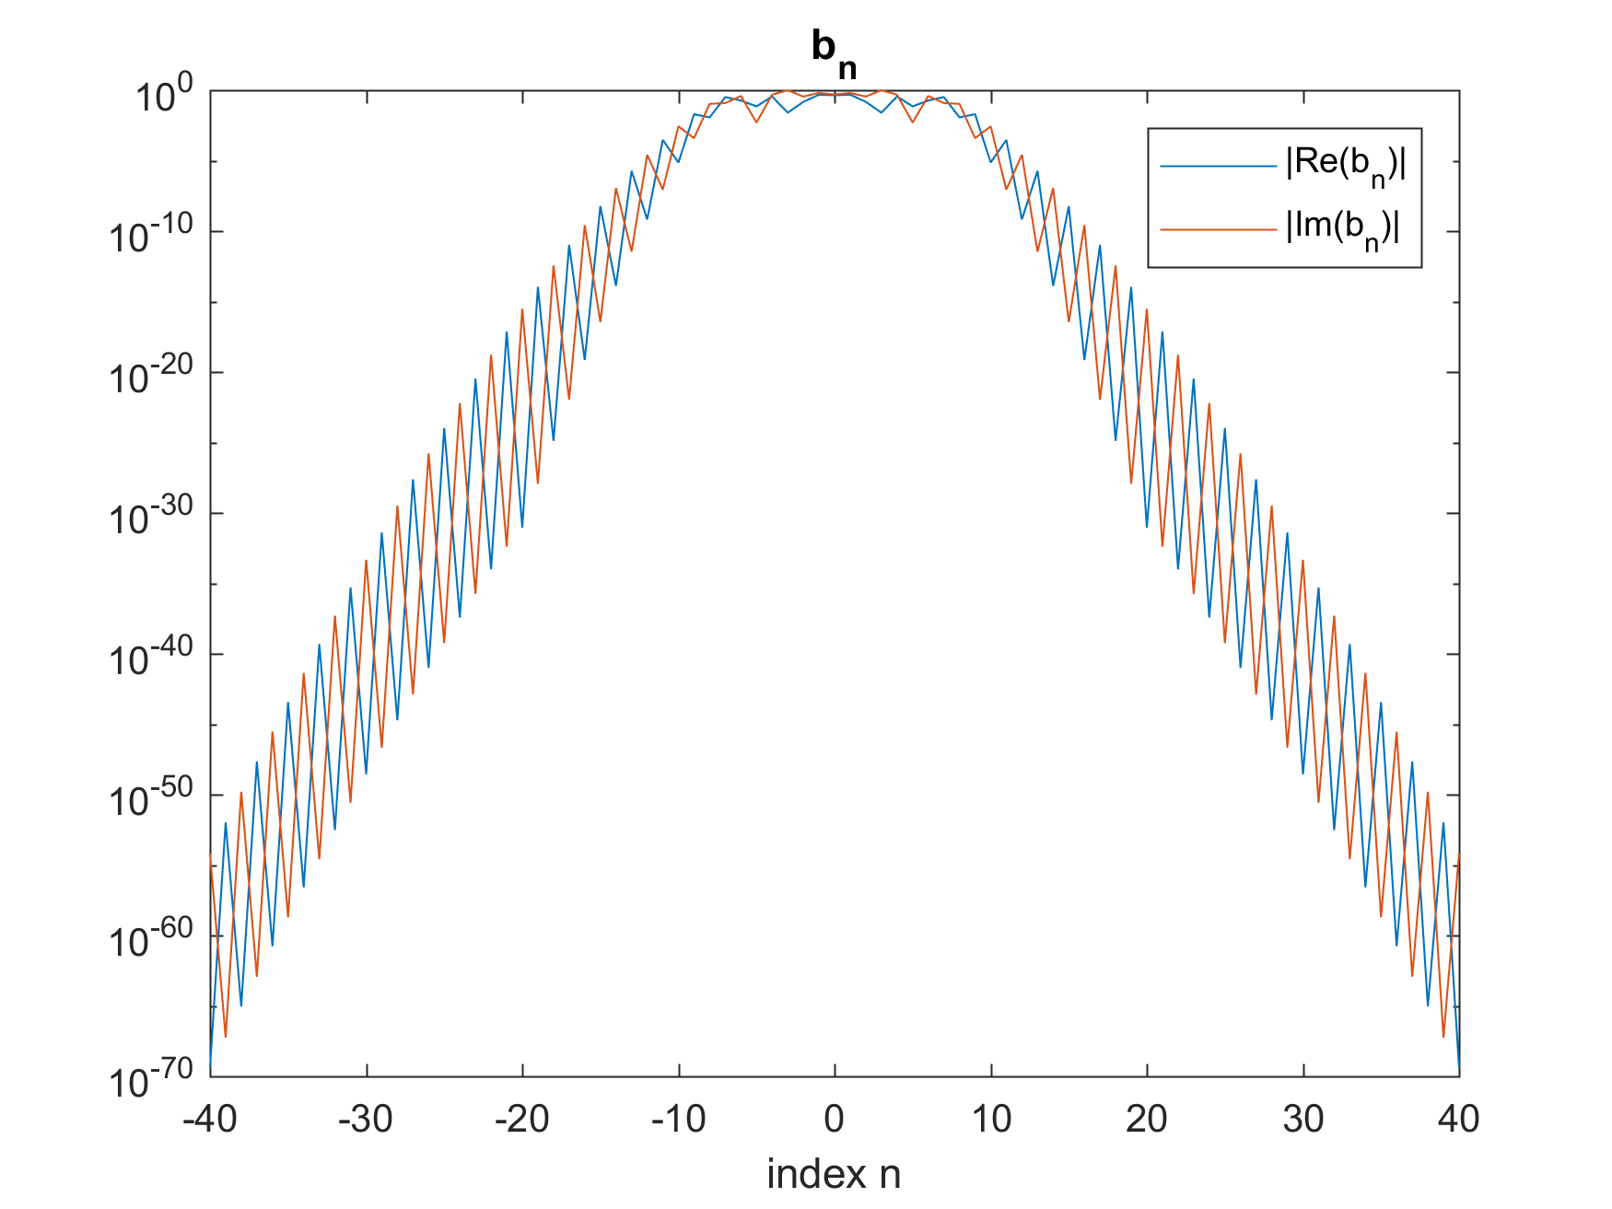

TM

TE

Also, the bistatic scattering width $σ_{2D}(ϕ)$ is obtained for both cases,

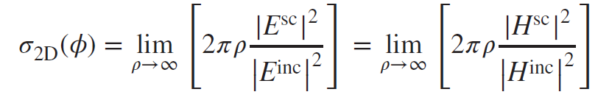

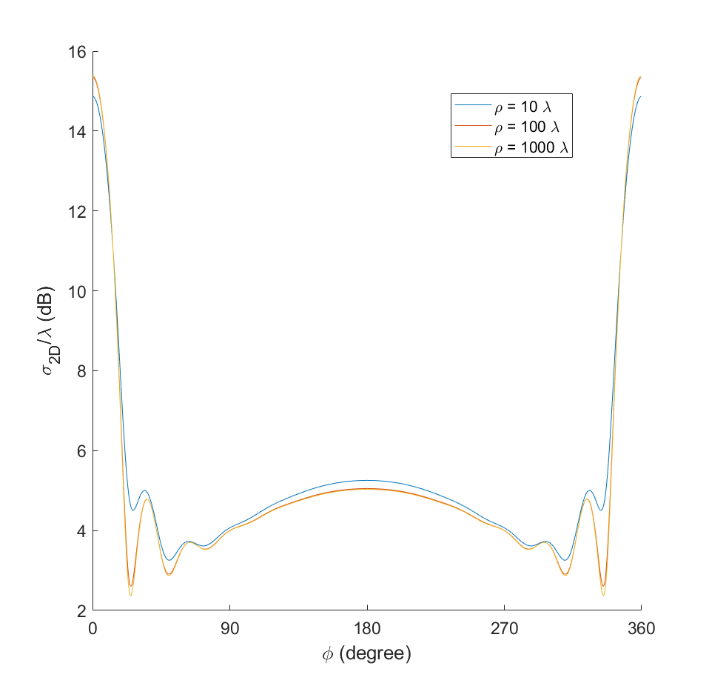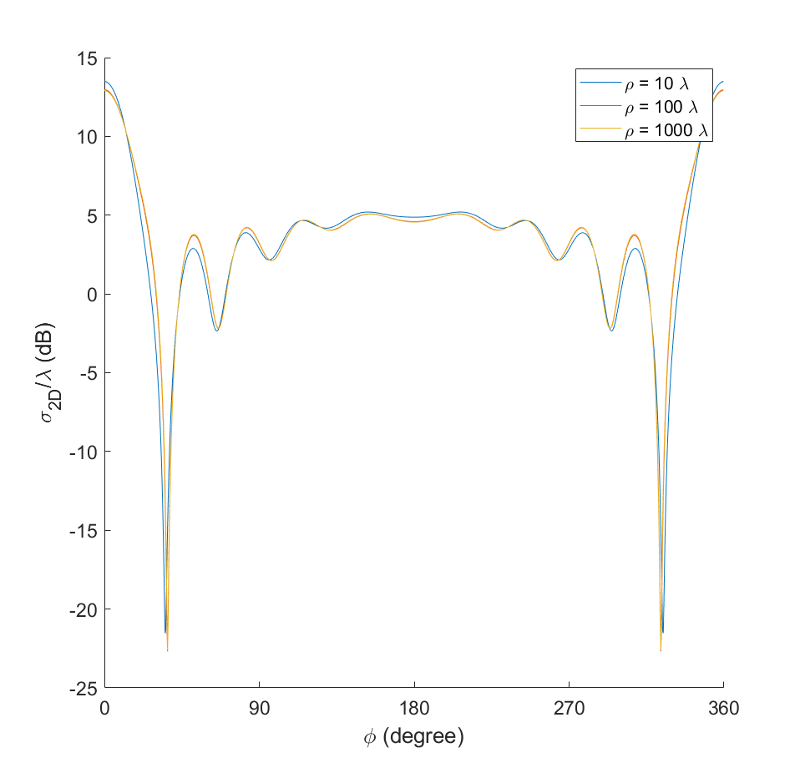

TM

TE

For the magnitude plots of scattered fields and total fields, and the t = 0 time domain snapshots of scattered fields and total fields, in a 10 λ x 10 λ region, please refer to the png images in the folder named 'r = 1 lambda'.

The other cases come in 'r = 0.6 lambda' and 'r = 2 lambda' folder.

# Conclusion

We successfully use the MoM to study the 2D scattering problem for an infinitely long conducting cylinder. The results are checked with the analytical solutions, to ensure the MoM is implemented correctly.

# Reference

[1] Jian-Ming Jin. *Theory and Computation of Electromagnetic Fields*. Wiley-IEEE Press, 2015.